Pizza Sales SQL queries

1. KPI’s

**Total Revenue:**

SELECT SUM(total_price)AS Total_Revenue FROM pizza_sales;

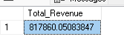

1. Average Order value

SELECT SUM(total_price) / COUNT(DISTINCT order_id)AS Avg_Order_value FROM pizza_sales

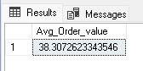

Total Pizza Sold

SELECT SUM(quantity) AS Total_Pizza_Sold FROM pizza_sales;

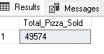

Total Orders

SELECT COUNT(DISTINCT order_id) AS Total_order FROM pizza_sales;

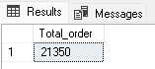

Average Pizza per order

SELECT CAST (CAST(SUM(quantity)AS DECIMAL(10,2)) /

CAST(COUNT(DISTINCT order_id) AS DECIMAL(10,2)) AS DECIMAL(10,2))AS Avg_Per_Order FROM pizza_sales;

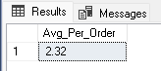

Percentage of sales pizza Category

SELECT pizza_category, SUM(total_price) AS Total_Sales, SUM(total_price)*100 /(SELECT SUM(total_price)

FROM pizza_sales WHERE MONTH(order_date)=1

) AS PCT

FROM pizza_sales

WHERE MONTH(order_date)=1

GROUP BY pizza_category;

Percentage of sales by Pizza Size

TOTal pizza Sold By Pizza Category

SELECT pizza_category ,SUM(quantity) AS Total_Pizza_Sold

FROM PizzaDB.dbo.pizza_sales

GROUP BY pizza_category;

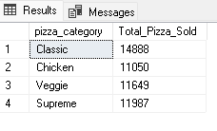

**Top 5 Best Sellers by Total pizza Sold**

SELECT TOP 5 pizza_name,SUM(quantity) AS Total_pizza_sold

FROM Pizza_sales

GRoUP BY pizza_name

ORDER BY Total_pizza_sold DESC ;

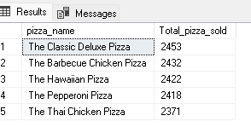

Bottom 5 Worst Seller by Total Piizza Sold

SELECT TOP 5 pizza_name,SUM(quantity) AS Total_pizza_sold

FROM Pizza_sales

GRoUP BY pizza_name

ORDER BY Total_pizza_sold ASC ;

